ANGELA VOWLES
vocals
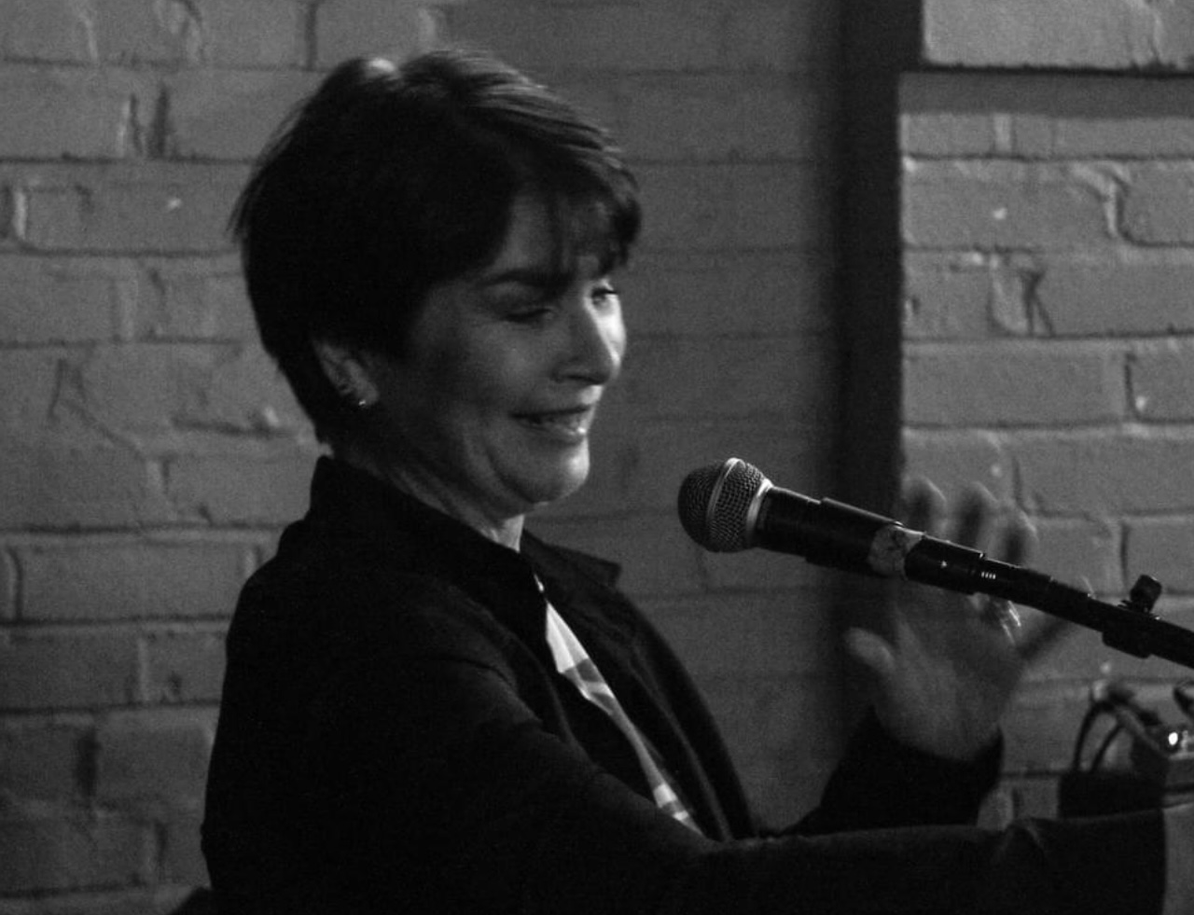

Angela is a Professional Doctorate Candidate at the University of Central Lancashire, Preston. Her practice-based research uses extended vowel sounds to create group performances and solo work.
Her non-verbal practice engages and encourages the voice, to improve technique, confidence, and stamina.
Angela has over 20 years’ experience in music performance, composition, and appraisal. She has a BA in Performance Technology with Music and an MA in Voice Production.
She has been teaching music in secondary schools, in and around Lancashire since 2004 and can assist with music qualifications such as BTEC, OCR and AQA.
If you love to sing and develop your unique sound or just want to release some endorphins and be part of a social group, contact Blackpool Music School.
Angela offers one-to-one sessions, small groups, workshops, and an opportunity to join Blackpool Music School Community Choir (BMSCC).

Performances:
Innate, Media Factory, Preston (2022)
Resonances of Me, CPRA Symposium, Preston (2022)
KRAus, Words and Music Festival, Liverpool (2022)
Talking to the Walls, Preston Live Arts Festival (2021)
Gossip (2021)
KRAus, Rock and Roll Marathon, Liverpool (2021)
Vowels and Berry, The Ferret, Preston (2019)
Entartete, The Ferret, Preston (2018)
Wonky Eye, Media Factory, Preston (2017)
Two Soups (2015-2017)

Workshops:
Sound Punch (2022) and Sound Out (2017- 2019)

Sound Installations:
The Iridescent Woman, Art B&B Blackpool (2022)
Entartete, Art, Harris Museum, Preston. (2019)
Shadow House, PPL, Preston (2018)

Choirs:
Methodist Community Choir, Weston-Super-Mare (2016 – 2017))
HPA Choir (2014-2017)
Tarleton Choir, Preston (2012)
Beacon Hill Choir (2004-2010)

