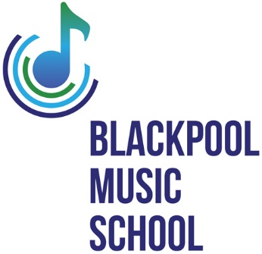

TERM DATES 2021/22

Term Dates 2021
Friday 22nd October – school closes – after class for 2 week
Saturday – 6th November - school returns
Saturday 18th December – school closes – after class for 2 weeks

Term Dates 2022
Monday 3rd January – school returns
Friday 11th February – school closes – after class for 1 week
Saturday 19th February – school returns
Friday 1st April – school closes – after class for 2 weeks
Saturday 16th April – school returns
Friday 27th May – school closes – after class for 1 week
Saturday 4th June – school returns
Friday 22th July – school closes – after class for 2 weeks
Saturday 6th August 2022 – school returns

