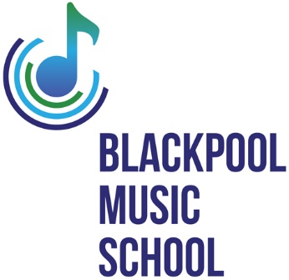
A BREATH OF FRESH AIR
(IN THE PIPE LINE)
ARE YOU A REGISTERED ASTHMASTIC OR HAVE A RESPORTORY PROBLEM?
ARE YOU AGED BETWEEN 7 TO 90 YEARS OLD?
WOULD YOU LIKE TO IMPROVE YOUR BREATHING?
BMS IS STARTING AN ELECTRONIC SAXOPHONE GROUP
- ONE GROUP FOR CHILDREN
- ONE GROUP FOR ADULTS
- GROUPS WILL COMPRISE OF 3 TO 4 STUDENTS
- INSTRUMENT PROVIDED (Free)

- WE WILL BE MONITORING OUR STUDENTS PROGRESS
- CONTROLLED BREATHING, AIDS BETTER BREATHING
- WE HOPE TO SHOW THE BENEFIT THIS WILL MAKE TO INDIVIDUAL STUDENTS

- COST - £24.00 PER CALENDAR MONTH FOR 42 WEEKS TUITION
- OUR TUTOR IS HIGHLY QUALIFIED AND DBS CHECKED

LOOKING FORWARD TO HEARING FROM YOU!
Contact E: blackpoolmusicschool@gmail.com
John – 07887 873309 or Karen – 07305 919816

