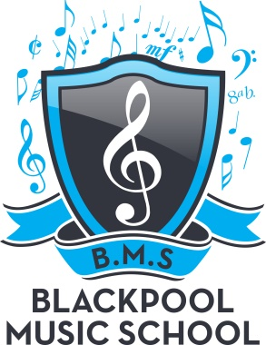

BLACKPOOL MUSIC SCHOOL
TERM DATES 2019/20

Saturday 3rd August 2019 School returns

Term Dates 2019
Friday 18th October – school closes – after class for 2 week
Saturday 2nd November – school returns
Friday 20th December – school closes – after class for 2 weeks
Term Dates 2020

Saturday 4th January – school returns
Friday 14th February – school closes – after class for 1 week
Saturday 22nd February – school returns
Friday 3rd April – school closes – after class for 2 weeks
Saturday 18th April – school returns
Friday 22nd May – school closes – after class for 1 week
Saturday 30th May – school returns
Friday 17th July – school closes – after class for 2 weeks
Saturday 1st August – school returns

