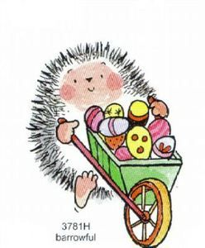 HEDGEHOG RESCUE
Invite you to an Easter
HOT POT meal (with crust and red cabbage)
Followed by
Gateaux and Cream
On
SATURDAY MARCH 31st 2018 @ 5PM
In
MOLYNEUX DRIVE COMMUNITY CENTRE, FY4 3JP.
COST - £3.50 per person.
Raffle for very large cuddly hedgehog toy with a very large easter egg, plus other prizes. Tickets 50p per strip of 5 on the day.
All profits go to saving the lives of sick and injured hedgehogs.
*********
From 7.00pm – 9.00pm there will be Fun Bingo with huge amounts of money to be won! £1 for a line and £2 for a full house!! Laughter, fun and banter is guaranteed. Tea/cake/coffee included in the price of
£5 per person.
Viv Critchley - 07912077330

