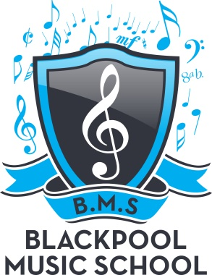

BLACKPOOL MUSIC SCHOOL
TERM DATES 2018/19

Saturday 1st September 2018 School returns

Term Dates 2018
Friday 19th October – school closes – after class for 1 week
Saturday 27th October – school returns
Friday 21st December – school closes – after class for 2 weeks

Term Dates 2019
Saturday 5th January – school returns
Friday 15th February – school closes – after class for 1 week
Saturday 23rd February – school returns
Friday 5th April – school closes – after class for 2 weeks
Saturday 20th April – school returns
Friday 24th May – school closes – after class for 2 week
Saturday 8nd June – school returns
Friday 19th July – school closes – after class for 2 weeks
Saturday 3rd August – school returns

